Contents

MACHINE LEARNING ALGORITHMS 3

TYPES OF ML ALGORITHIM 4

TYPES OF MACHINE LEARNING 4

SUPERVISED LEARNING 4

TRAINING PROCESS 5

CLASSIFICATION (BINARY CLASSIFICATION) 6

REGRESSION ALGORITHM 8

UNSUPERVISED LEARNING 13

LEARNING TECHNIQUES IN UNSUPERVISED LEARNING 13

CLUSTERING 13

ASSOCIATION RULE LEARNING 13

DIMENSIONALITY REDUCTION 14

ANOMALY DETECTION 14

SUPERVISED V/S UN-SUPERVISED LEARNING 14

FEATURE SCALING 14

NORMALIZATION 15

STANDARDIZATION 16

EXAMPLE – NORMALIZATION 16

TRAINING ML MODELS 17

LIFECYCLE 17

FEATURE ENGINEERING 18

MACHINE LEARNING ALGORITHMS CLASSIFICATION 18

ANOMALY DETECTION ALGORITHM 18

CLUSTERING ALGORITHM 18

DATA PRE-PROCESSING USING PYTHON 19

DATA PROCESSING USING PYTHON 24

REGRESSION 24

MULTIPLE LINEAR REGRESSION 25

POLYNOMIAL REGRESSION 25

SUPPORT VECTOR REGRESSION 25

DECISION TREE REGRESSION 25

RANDOM FOREST REGRESSION 25

# MACHINE LEARNING ALGORITHMS

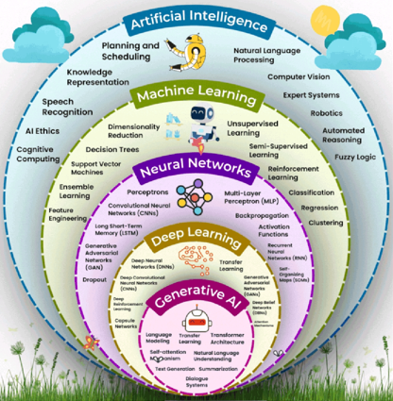

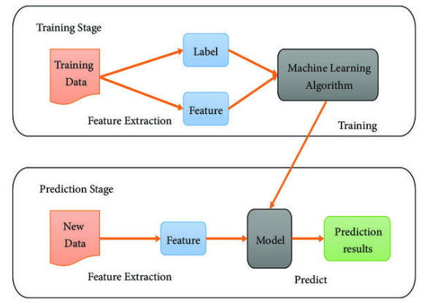

* Machines learn by observing examples and identifying patterns, similar to how humans (or babies) learn through experience.
* Machine learning relies heavily on data — both its **quality** and **quantity** — to train models effectively.

Steps

Step 1: The data is used to train algorithms.

Step 2: Algorithms analyze data to find patterns, once it recognize the pattern from the data, we can it a model

Step 3: Then models capable can able to do prediction for the new & unseen data.

|  |
| --- |
| **Algorithms**: These are sets of rules, often based on statistical and mathematical techniques, that guide the learning process. |

## TYPES OF ML ALGORITHIM

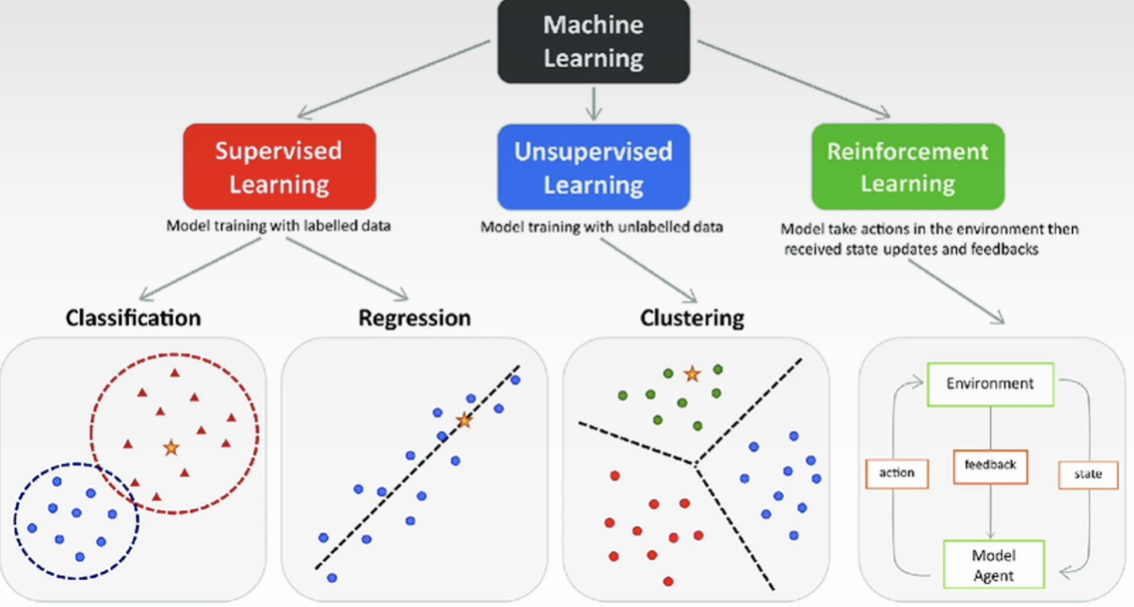

## TYPES OF MACHINE LEARNING

## SUPERVISED LEARNING

* The name supervised learning originates from the idea that training a machine while using this type of approach is like how humans are learning under the supervision of a teacher.

|  |
| --- |
| Analogy  In regular school class, we have a group of students and a teacher. During a lecture about some specific topic, the teacher will provide several examples while teaching something. The students will use those examples to analyze and memorize them, something that will help them to extract the patterns from those examples. At a later stage, based on the information provided, the students will be able to solve similar problems. Overall, the teacher decided what kind of examples to present and how many, he or she basically supervised the learning process. |

* **In supervised learning, we train machines by providing them with a set of examples, each provided example is a pair consisting of an input object and the desired output value for that object, it’s called label data set.**

EXAMPLE: labelled data set

|  |  |  |  |  |
| --- | --- | --- | --- | --- |
| **fur_length** | **ear_shape** | **tail_length** | **label** | *Based on features like “fur_length”, “ear_shape” and “tail_length” we label the data like”cat” & “dog”* |
| short | pointy | long | cat |
| long | floppy | medium | dog |
| medium | pointy | short | cat |
| long | floppy | long | Dog |

* Now based on this labelled data the model learns my identifying the pattern.
* After learning the pattern, it can able to do predictions for new data inputs.

### TRAINING PROCESS

|  |
| --- |
| The model learns a function (y=f(x))(using the training data) that maps the inputs to desired outputs that makes the predictions based on that function |

|  |  |
| --- | --- |
|  | * "X" is the input into the machine which can be a group of values called "features". * "Y" is the output of that machine, the target value. * Functions with the input x are basically some mathematical transformation function or mapping function discovered by the algorithm doing the training process |

|  |  |  |  |  |  |  |  |  |
| --- | --- | --- | --- | --- | --- | --- | --- | --- |
| **RELATION BETWEEN MAPPING FUNCTION AND ML ALGORITHM**  **WHAT IS A MAPPING FUNCTION?**   * Think of a mapping function as a recipe or rule that tells us how to turn input into output. * In machine learning, this function is what the algorithm is trying to learn from data.   **REAL-WORLD EXAMPLE: PREDICTING HOUSE PRICES:** Let’s say we want to predict the price of a house based on its size.   * Input (X): Size of the house (e.g., 1000 sq ft) * Output (Y): Price of the house (e.g., ₹50 lakhs)   The ML algorithm’s job is to learn a function like:  **Price = f(Size)**  This function could be:   * A straight line (if price increases steadily with size) * A curve (if price increases faster for bigger houses)   **HOW ML ALGORITHM USES THE MAPPING FUNCTION?**   1. **Step 1**: We give it data: Sizes and prices of many houses. 2. **Step 2**: It finds a pattern: Learns the best function (mapping) that connects size to price. 3. **Step 3**: We use it to predict: For a new house size, it uses the function to predict the price.   Example in Simple Terms (Training Data)   |  |  | | --- | --- | | Size (sq ft) | Price (₹ lakhs) | | 1000 | 50 | | 1500 | 75 | | 2000 | 100 |  * The ML algorithm might learn: **Price = 0.05 X Size** * So, for a 1200 sq ft house: **Price = 0.05 X 1200 = ₹60** * A mapping function is the rule that connects input to output. * An ML algorithm learns this rule from data. * Once learned, it can make predictions on new data.   **Here's a simple chart that shows how a machine learning algorithm learns a mapping function from house size to price:**  **A graph with a red line and blue dots  AI-generated content may be incorrect.**   * *Blue dots: Real data points (house size vs. price).* * *Red line: The learned function (Price = 0.05 × Size), which the ML algorithm uses to make predictions***.**   **This is a basic example of how ML finds a pattern (a mapping function) in data and uses it to predict outcomes.** |

Two typical tasks performed by Supervised Learning

1. CLASSIFICATION
2. REGRESSION

### CLASSIFICATION (BINARY CLASSIFICATION)

* Classification involves assigning category labels to new observations based on past observations and their labels(as it a type of supervised learning)
* **Classification** is a type of supervised learning where the goal is to **predict a category or class**. Instead of predicting a number (like in regression), classification predicts a **label**.

#### BINARY CLASSIFICATION

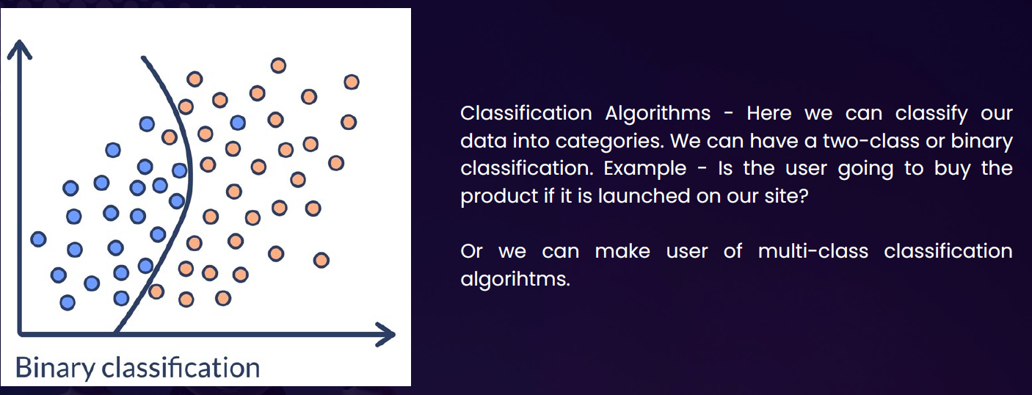

Real-Life Example: Email Spam Detection

Imagine if we have a bunch of emails, and each one is labeled as either:

* **Spam**
* **Not Spam**

We train a machine learning model with this data. The model learns patterns like:

1. Emails with “win money” → likely spam
2. Emails from your contacts → likely not spam

Once trained, the model can classify **new emails** as spam or not spam.

Other Examples of Classification

|  |  |
| --- | --- |
| Problem | Classes (Labels) |
| Disease diagnosis | Sick / Healthy |
| Image recognition | Cat / Dog / Bird |
| Customer feedback sentiment | Positive / Negative / Neutral |
| Loan approval | Approved / Rejected |

#### MULTICLASS CLASSIFICATION

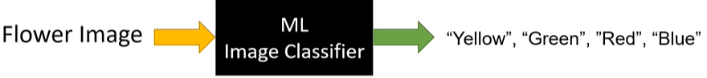

Multiclass classification is when a machine learning model predicts **one label out of three or more possible categories**.

|  |  |
| --- | --- |
| **Problem** | **Classes (Labels)** |
| Handwritten digit recognition | 0 to 9 |
| Animal image classification | Cat / Dog / Bird / Horse |
| Exam grading | A / B / C / D / F |

* SVM(Support Vector Machines) are one such classification ML Model

### REGRESSION ALGORITHM

|  |  |  |  |  |  |  |  |  |  |
| --- | --- | --- | --- | --- | --- | --- | --- | --- | --- |
| What is regression (General Concept): Regression helps us find a relationship between input and output and use that to predict future values.  Real-Life Example: Let’s say we want to predict the price of a house based on its size.   |  |  | | --- | --- | | Size (sq ft) | Price (₹ in lakhs) | | 1000 | 50 | | 1500 | 75 | | 2000 | 100 |   Now, if someone asks: "What would be the price of a 1800 sq ft house?" Regression helps us predict that — maybe around ₹90 lakhs. | **What the Graph Shows:**   * **Blue dots**: Actual data points (house size vs. price) * **Green line**: The regression line — it shows the trend the model has learned * **Red dot**: The predicted price for a **1800 sq ft** house — around **₹90 lakhs** |

* **Regression** is a type of **supervised learning** where the goal is to **predict a continuous value** (a number) based on input data.

**Y= aX+b**

**Here Y= Dependent Variable & X= Independent Variable**

* In regression analysis we are continuously trying to find out the value of dependent variables. i.e. the value of y based on one or more predictors(X) which is the independent variable.

Real-World Example: Predicting House Prices

|  |  |  |  |  |  |  |  |  |  |  |  |  |  |  |  |  |  |  |  |  |  |
| --- | --- | --- | --- | --- | --- | --- | --- | --- | --- | --- | --- | --- | --- | --- | --- | --- | --- | --- | --- | --- | --- |
| Imagine a real estate agent and want to **predict the price of a house** based on certain features like:   * Size of the house (in square feet) * Number of bedrooms * Location * Age of the house | You collect data from past house sales. Each row in your dataset looks like this:   |  |  |  |  |  | | --- | --- | --- | --- | --- | | **Size (sqft)** | **Bedrooms** | **Age (years)** | **Location Score** | **Price (₹)** | | 1200 | 3 | 5 | 8 | 45,00,000 | | 1500 | 4 | 2 | 9 | 60,00,000 | | 1000 | 2 | 10 | 6 | 35,00,000 | |

* Now, we can train a **regression model** using this data. The model learns the relationship between the features and the price. Later, when we get a new house with known features but unknown price, the model can **predict the price**.

Real-Life Examples

|  |  |  |
| --- | --- | --- |
| **Problem** | **Input Features** | **Output (Continuous Value)** |
| Predict house price | Size, location, age | ₹50,00,000 |
| Predict temperature | Date, time, humidity | 32.5°C |
| Predict height of a child | Age, gender, parents' height | 145.2 cm |
| Predict fuel efficiency | Engine size, weight, speed | 18.7 km/l |

In each case, the **output is a number** that can vary smoothly — not just a fixed set of options.

**GRAPHICAL REPRESENTATION**

* Each dot represents a house.
* The x-axis is the size of the house (in square feet).
* The y-axis is the price of the house (in INR).
* The pattern shows that as house size increases, the price also tends to increase — this is the kind of relationship a regression model learns.
* Red line: The regression line — this is the model's prediction of house price based on size.
* The most common form of regression analysis is linear regression

#### LINEAR REGRESSION

* **Linear regression** is a fundamental concept in statistics and machine learning used to model the relationship between a **dependent variable** (target) and one or more **independent variables** (predictors or features).
* **Key Idea:** Linear regression assumes that there is a **linear relationship** between the input (X) and output (Y), meaning:

|  |  |
| --- | --- |
| **Y = aX + b + error** | * **Y** is the dependent variable (what we want to predict), * **X** is the independent variable (input), * **a** is the slope (how much Y changes with X), * **b** is the intercept (value of Y when X = 0), * **error** is the difference between the predicted and actual value. |

##### TYPES OF LINEAR REGRESSION

1. Simple Linear Regression: 1 independent variable: Y = aX + b
2. Multiple Linear Regression:
   1. more than 1 independent variable Y = a1X1 + a2X2 + ... + anXn + b
   2. Example: Estimating house prices based on size, location, etc

|  |
| --- |
| **Goal: Find the best values of a and b so that the predicted Y values are as close as possible to the actual Y values — usually by minimizing the mean squared error (MSE) between them.** |

##### EXAMPLE

* In this example we will use the data set iris.csv as a training data and then predict the species for new unseen data
* Data Set : [Docs/Machine Learning/Linear-Regression-Example/Iris.csv at master · avishekhsinhaRepo/Docs](https://github.com/avishekhsinhaRepo/Docs/blob/master/Machine%20Learning/Linear-Regression-Example/Iris.csv)

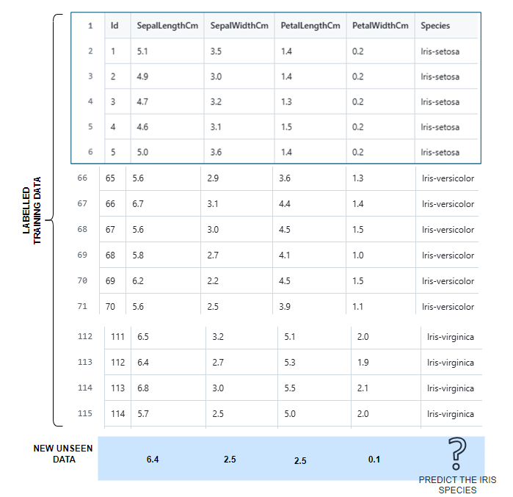

Note : Iris is a flower – based on the pertals and sepals dimension we are going to predict the iris species

|  |  |  |
| --- | --- | --- |
| Some common Pandas operations | | |
| **import pandas as pd**  **from sklearn.linear_model import LogisticRegression**  **data = pd.read_csv("./resources/Iris.csv")**  **print(data.head())**  **print(data.shape)** | * The code loads Iris dataset using pandas [read_csv()](vscode-file://vscode-app/c:/Program%20Files/Microsoft%20VS%20Code/resources/app/out/vs/code/electron-sandbox/workbench/workbench.html) function. * [data.head()](vscode-file://vscode-app/c:/Program%20Files/Microsoft%20VS%20Code/resources/app/out/vs/code/electron-sandbox/workbench/workbench.html) displays the first 5 rows by default, giving us a quick preview of the data structure and values. * The [data.shape](vscode-file://vscode-app/c:/Program%20Files/Microsoft%20VS%20Code/resources/app/out/vs/code/electron-sandbox/workbench/workbench.html" \o ") shows the dimensions (rows, columns) of the dataset, which helps understand the dataset size. |
| data.head()    data.shape: **(150,6)** | | |
| **specific_data= data[["Id","Species"]]**  **print(specific_data.head())** | This creates a new DataFrame containing only the "Id" and "Species" columns. This is useful for:   * Focusing on specific variables of interest * Creating labels for machine learning (Species would be the target variable) * Reducing memory usage when working with large datasets |

MODEL TRAINING AND PREDICTION

|  |  |
| --- | --- |
| **data = pd.read_csv("./resources/Iris.csv")**  **X= data.drop(columns=['Id','Species'])**  **Y=data['Species']**  **print (X.head)**  **print(Y.head)**  **ml_model=LogisticRegression()**  **ml_model.fit(X.values, Y)**  **ml_predictions=ml_model.predict([[6.4,2.5,0.5,0.1]])**  **print(ml_predictions)**  OUTPUT: Prediction of Iris species | The code creates and trains a logistic regression model   * [X](vscode-file://vscode-app/c:/Program%20Files/Microsoft%20VS%20Code/resources/app/out/vs/code/electron-sandbox/workbench/workbench.html) represents the **features** (input variables) - all columns except 'Id' and 'Species'. * The [drop()](vscode-file://vscode-app/c:/Program%20Files/Microsoft%20VS%20Code/resources/app/out/vs/code/electron-sandbox/workbench/workbench.html) method removes these columns, leaving only the numerical measurements like petal length, sepal width, etc. * [Y](vscode-file://vscode-app/c:/Program%20Files/Microsoft%20VS%20Code/resources/app/out/vs/code/electron-sandbox/workbench/workbench.html) represents the **target variable** (what we want to predict) - the species of each iris flower. * [X.values](vscode-file://vscode-app/c:/Program%20Files/Microsoft%20VS%20Code/resources/app/out/vs/code/electron-sandbox/workbench/workbench.html) converts the pandas DataFrame to a NumPy array, which is often more efficient for scikit-learn algorithms. * The [fit()](vscode-file://vscode-app/c:/Program%20Files/Microsoft%20VS%20Code/resources/app/out/vs/code/electron-sandbox/workbench/workbench.html) method trains the model by learning the relationship between the features and species labels. * Finally, the code makes a prediction on new data: * This predicts the species for a flower with measurements: 6.4, 2.5, 0.5, 0.1. The input must be a 2D array (notice the double brackets [[]]) because scikit-learn expects multiple samples, even when predicting just one. |
| **X.head** | |
| **Y.head** | |

## UNSUPERVISED LEARNING

* **Unsupervised learning** is a type of machine learning where the model learns from data **without any labels**.
* It tries to find **patterns, structures, or groupings** in the data on its own.
* Imagine we have a bunch of photos of animals, but we don’t tell the model which ones are cats, dogs, or birds. The model looks at the photos and **groups similar ones together** — maybe all the cats in one group, dogs in another, and so on.
* **Hence – Unsupervised learning involves analyzing and clustering unlabeled datasets to discover hidden patterns or data groupings without human intervention.**

## LEARNING TECHNIQUES IN UNSUPERVISED LEARNING

|  |  |  |  |  |  |  |  |  |  |  |  |  |  |  |  |
| --- | --- | --- | --- | --- | --- | --- | --- | --- | --- | --- | --- | --- | --- | --- | --- |
| What is a Learning Technique in Machine Learning?  A **learning technique** is the **method or approach** used by a machine learning algorithm to **learn patterns** from data.  Think of it like this: : Just like humans use different ways to learn (reading, practicing, watching videos), machines also have different **techniques** to learn from data.  **🔸 In Unsupervised Learning, common learning techniques include:**   |  |  |  | | --- | --- | --- | | Technique | What It Does | Example Use Case | | Clustering | Groups similar data points | Customer segmentation | | Association Rules | Finds relationships between items | Market basket analysis | | Dimensionality Reduction | Simplifies data by reducing features | Visualizing high-dimensional data | | Anomaly Detection | Identifies unusual data points | Fraud detection | |

### CLUSTERING

Groups similar data points together based on patterns.

* **Goal**: Find natural groupings in data.
* **Examples**:
  + Customer segmentation
  + Grouping news articles
* **Algorithms**:
  + K-Means
  + DBSCAN
  + Hierarchical Clustering

### ASSOCIATION RULE LEARNING

Finds relationships between variables in large datasets.

* **Goal**: Discover rules like “If A, then B.”
* **Examples**:
  + Market basket analysis (e.g., people who buy bread also buy butter)
* **Algorithms**:
  + Apriori
  + FP-Growth

### DIMENSIONALITY REDUCTION

Reduces the number of features while keeping important information.

* **Goal**: Simplify data, remove noise, visualize high-dimensional data.
* **Examples**:
  + Visualizing customer behavior
  + Preprocessing for other ML models
* **Algorithms**:
  + PCA (Principal Component Analysis)
  + t-SNE
  + UMAP

### ANOMALY DETECTION

Identifies data points that don’t fit the pattern.

* **Goal**: Detect outliers or rare events.
* **Examples**:
  + Fraud detection
  + Network intrusion detection
* **Algorithms**:
  + Isolation Forest
  + One-Class SVM
  + Autoencoders

## SUPERVISED V/S UN-SUPERVISED LEARNING

## FEATURE SCALING

Feature scaling **transforms the values of features to be on a similar scale**, typically to improve model performance and training stability.

We can understand feature scaling using the example below. Note: ***Feature scaling is always applied at column level***

There are 2 main techniques of feature scaling

1. **NORMALIZATION**
2. **STANDARDIZATION**

### NORMALIZATION

|  |  |
| --- | --- |
|  | * The normalization value lies between the closed interval of [0;1] |

|  |  |  |
| --- | --- | --- |
| **X1 (Price)** | **X-XMIN** | **Normalized Value(X1)** |
| $179.43 | $0.00 | 0.00 |
| $641.87 | $179.43 | 0.39 |
| $556.30 | $376.87 | 0.814959779 |
| $578.47 | $116.03 | 0.250908226 |
| $591.12 | $411.69 | 0.890256033 |
|  |  |  |
| X1-MAX |  | $641.87 |
| X1-MIN |  | $179.43 |
| X1MAX - X1MIN |  | **$462.44** |

### STANDARDIZATION

|  |  |  |
| --- | --- | --- |
|  | µ | Average |
|  | Standard Deviation |
| * The value is lies in closes interval of [-3,3] * If data has some outliers – it will exist outside this range | |

### EXAMPLE – NORMALIZATION

1. Let's imagine we have a data set where we have two columns, annual income of a person and their age of

a blue, purple and red person.

1. **We must identify whether the purple person is like a “red” person or “blue” person . This is the task of clustering data. For that we need to do normalization of data as the units of the data is not uniform**

1. After normalizing, our values will look like above. Hence with the normalized data – From salary column perspective. The purple person is almost right in the middle between the red and the blue people(0.44), whereas in the age column, the purple person is closest to the blue person.

|  |
| --- |
| Scikit-learn (also written as scikit-learn or sklearn) is a powerful and widely used open-source machine learning library for the Python. It provides simple and efficient tools for:  🔍 Key Features   * Classification: Identifying which category an object belongs to (e.g., spam detection). * Regression: Predicting a continuous-valued attribute (e.g., house prices). * Clustering: Grouping similar data points (e.g., customer segmentation). * Dimensionality Reduction: Reducing the number of features (e.g., PCA). * Model Selection: Comparing, validating, and choosing parameters and models. * Preprocessing: Feature extraction, normalization, and transformation.   🧰 Built On  Scikit-learn is built on top of:   * NumPy: For numerical operations. * SciPy: For scientific computing. * Matplotlib: For plotting (indirectly used). * joblib: For model persistence and parallel processing. |

# TRAINING ML MODELS

1. As part of the prerequisite of most machine learning projects, we need a training data set. A training data set is a large group of labeled examples. A machine-learning system is going to learn patterns inside the training data set and store that knowledge in something that is called a **model**.
2. This model is supposed to define as close as possible the relationship between features and the target label. In a common type of machine learning method called "supervised learning" the way to create this kind of model is based on analyzing a large group of labeled examples.
3. Once we have trained our model with those labeled examples, we can use that trained model to predict the label on unlabeled examples.

## LIFECYCLE

The lifecycle of a model in a machine learning system, we have two main phases

1. **TRAINING PHASE (LEARNING PHASE):** The main idea is to utilize or use some learning algorithms that will build the model using the training data set.
2. **INFERENCE PHASE (LEARNING PHASE):** In machine learning inference means applying the trained model in an actual machine learning system working in a production environment for making ongoing predictions.

## FEATURE ENGINEERING

# MACHINE LEARNING ALGORITHMS CLASSIFICATION

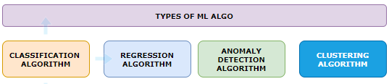

## ANOMALY DETECTION ALGORITHM

* This is used to detect if data deviates from the norm
* Example: used to detect fraudulent credit card purchase

## CLUSTERING ALGORITHM

# DATA PRE-PROCESSING USING PYTHON

|  |  |
| --- | --- |
|  | * In this example we will perform data preprocessing step on this following data * It’s a user profile data – of an ecommerce website with a flag which says whether user has made purchase or not! * As a data processing step – we create two entities –  1. The first is **the matrix of features**, which contains separately these three columns (country, age, salary.) 2. And second is the dependent variable vector, which is last column(“Purchased”), because that's the column we want to predict.   *Note : This is exactly what we must do in this first data pre-processing phase.* |

|  |  |
| --- | --- |
| Step 1: Importing the libraries | import numpy as np import matplotlib.pyplot as plt import pandas as pd |
| Step 2: Importing the dataset | dataset = pd.read_csv('Data.csv') X = dataset.iloc[:, :-1].values y = dataset.iloc[:, -1].values  OUTPUT  [['France' 44.0 72000.0]  ['Spain' 27.0 48000.0]  ['Germany' 30.0 54000.0]  ['Spain' 38.0 61000.0]  ['Germany' 40.0 nan]  ['France' 35.0 58000.0]  ['Spain' nan 52000.0]  ['France' 48.0 79000.0]  ['Germany' 50.0 83000.0]  ['France' 37.0 67000.0]]  ['No' 'Yes' 'No' 'No' 'Yes' 'Yes' 'No' 'Yes' 'No' 'Yes'] |
| Step 3: Missing Data   * For missing data, we can make use of Python library Scikit-learn. It is an open-source machine learning library built on top of **NumPy**, **SciPy**, and **matplotlib**. * It provides simple and efficient tools for data mining and data analysis. * For example - For missing salary - We will replace the missing salary with average salary in the column   **from sklearn.impute import SimpleImputer**  **imputer= SimpleImputer(missing_values=np.nan, strategy='mean') imputer.fit(X[:, 1:3]) # Assuming columns 1 and 2 have missing values X[:, 1:3] = imputer.transform(X[:, 1:3]) # Transform the data to fill missing values**   * SimpleImputer from scikit-learn to fill missing values (NaN) in specific columns of the feature matrix X with the mean of each column. * It fits the imputer on columns 1 and 2 (indexing starts at 0), replaces missing values with the computed mean | |

Step 4: Encoding the categorial data

* Encoding categorical data is **crucial in machine learning** because most ML algorithms require **numerical input** to perform mathematical computations.

Common Encoding Techniques

|  |  |  |
| --- | --- | --- |
| Technique | Description | Best For |
| Label Encoding | Assigns A Unique Number To Each Category | Ordinal Data (E.G., "Low", "High") |
| One-Hot Encoding | Creates Binary Columns For Each Category | Nominal Data (E.G., "Red", "Blue") |
| Ordinal Encoding | Encodes Categories With Meaningful Order | Ordered Categories |
| Target Encoding | Replaces Categories With The Mean Of The Target Variable For Each Category | High-Cardinality Categorical Data |

Example

Suppose we have a column Fuel Type with values: ["Petrol", "Diesel", "Electric"]

* Label Encoding: Petrol → 0, Diesel → 1, Electric → 2 (May imply an order that doesn’t exist)
* One-Hot Encoding:

| Petrol | Diesel | Electric |
| --- | --- | --- |
| 1 | 0 | 0 |
| 0 | 1 | 0 |
| 0 | 0 | 1 |

Why Encode Categorical Data?

* ML Models Work with Numbers
  1. Algorithms like linear regression, decision trees, and neural networks **cannot interpret text** or labels directly. They need **numerical representations** to process the data.
* Preserves Information
  1. Encoding transforms categories into numbers **without losing the meaning** of the data. For example, converting "Red", "Blue", "Green" into numerical form allows the model to still distinguish between them.
* Improves Model Performance
  1. Proper encoding helps the model **understand relationships** between variables, which can lead to **better predictions** and **faster training**.
* Avoids Bias from Arbitrary Numbers
  1. Some encoding methods (like **One-Hot Encoding**) prevent the model from assuming an **ordinal relationship** where none exists.
  2. For example, assigning "Low", "Medium", "High" as 1, 2, 3 implies a ranking, which may or may not be appropriate.

CODE

Taking the example further will apply “Hot Encoding” of “County” column and “label encoding” to the “Purchased” column.

One Hot Encoding OF Country Column

|  |
| --- |
| from sklearn.preprocessing import OneHotEncoder  ct = ColumnTransformer(transformers=[('encoder', OneHotEncoder(),[0])],remainder='passthrough') X = np.array(ct.fit_transform(X)) # Apply one-hot encoding to the first column |

LABELLED Encoding OF Country Column

|  |
| --- |
| from sklearn.preprocessing import LabelEncoder  le = LabelEncoder() y = le.fit_transform(y) # Apply label encoding to the dependent variable |

EXAMPLE – CODING EXERCISE

Dataset

|  |  |  |  |  |  |  |  |  |  |  |  |
| --- | --- | --- | --- | --- | --- | --- | --- | --- | --- | --- | --- |
| PassengerId | Survived | Pclass | Name | Sex | Age | SibSp | Parch | Ticket | Fare | Cabin | Embarked |
| 2 | 1 | 1 | Cumings, Mrs. John Bradley (Florence Briggs Thayer) | female | 38 | 1 | 0 | PC 17599 | 71.2833 | C85 | C |
| 4 | 1 | 1 | Futrelle, Mrs. Jacques Heath (Lily May Peel) | female | 35 | 1 | 0 | 113803 | 53.1 | C123 | S |
| 7 | 0 | 1 | McCarthy, Mr. Timothy J | male | 54 | 0 | 0 | 17463 | 51.8625 | E46 | S |
| 11 | 1 | 3 | Sandstrom, Miss. Marguerite Rut | female | 4 | 1 | 1 | PP 9549 | 16.7 | G6 | S |
| 12 | 1 | 1 | Bonnell, Miss. Elizabeth | female | 58 | 0 | 0 | 113783 | 26.55 | C103 | S |
| 22 | 1 | 2 | Beesley, Mr. Lawrence | male | 34 | 0 | 0 | 248698 | 13 | D56 | S |

Coding Exercise 3: Encoding Categorical Data for Machine Learning

**1**: Import required libraries - Pandas, Numpy, and required classes for this task - ColumnTransformer, OneHotEncoder, LabelEncoder.

**2**: Start by loading the Titanic dataset into a pandas data frame. This can be done using the pd.read_csv function. The dataset's name is 'titanic.csv'.

**3**: Identify the categorical features in your dataset that need to be encoded. You can store these feature names in a list for easy access later.

**4**: To apply OneHotEncoding to these categorical features, create an instance of the ColumnTransformer class. Make sure to pass the OneHotEncoder() as an argument along with the list of categorical features.

**5**: Use the fit_transform method on the instance of ColumnTransformer to apply the OneHotEncoding.

**6**: The output of the fit_transform method should be converted into a NumPy array for further use.

**7**: The 'Survived' column in your dataset is the dependent variable. This is a binary categorical variable that should be encoded using LabelEncoder.

**8.**  Print the updated matrix of features and the dependent variable vector

|  |
| --- |
| # Importing the necessary libraries import pandas as pd import numpy as np from sklearn.compose import ColumnTransformer from sklearn.preprocessing import OneHotEncoder, LabelEncoder  # Load the dataset dataset = pd.read_csv("titanic.csv")  # Identify the categorical data categorical_features = ['Sex', 'Embarked', 'Pclass']  # Implement an instance of the ColumnTransformer class  ct = ColumnTransformer(transformers=[('encoder', OneHotEncoder(),categorical_features)],remainder='passthrough')  # Apply the fit_transform method on the instance of ColumnTransformer ct_fit = ct.fit_transform(dataset) # Apply one-hot encoding to the first column  # Convert the output into a NumPy array X = np.array(ct.fit_transform(dataset))  # Use LabelEncoder to encode binary categorical data le = LabelEncoder()  Y = le.fit_transform(dataset["Survived"]) # Apply label encoding to the dependent variable  # Print the updated matrix of features and the dependent variable vector print(X) print(Y) |

Step 5: Training Versus Test Data

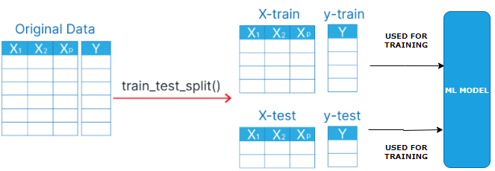

|  |
| --- |
| from sklearn.model_selection import train_test_split  x_train, x_test, y_train, y_test = train_test_split(X, y, test_size=0.2, random_state=1) |

The train_test_split method arrays or matrices into random train and test subsets.

Parameters:

* X: Features (input data).
* y: Labels (target data).
* test_size: Fraction or number of samples to use as the test set (e.g., 0.2 means 20% for testing).
* train_size: Fraction or number of samples for training (optional, usually inferred).
* random_state: Seed for random number generator (ensures reproducibility).
* shuffle: Whether to shuffle data before splitting (default is True).
* stratify: Ensures the split preserves the proportion of labels (optional, usually for classification).
* Returns: Splits the data into x_train, x_test, y_train, and y_test.

EXAMPLE

1. Import necessary Python libraries: pandas, train_test_split from sklearn.model_selection, and StandardScaler from sklearn.preprocessing.
2. Load the Iris dataset using Pandas read.csv. Dataset name is iris.csv.
3. Use train_test_split to split the dataset into an 80-20 training-test set.
4. Apply random_state with 42 value in train_test_split function for reproducible results.
5. Print X_train, X_test, Y_train, and Y_test to understand the dataset split.
6. Use StandardScaler to apply feature scaling on the training and test sets.
7. Print scaled training and test sets to verify feature scaling.

Step 6: Feature Scaling

# DATA PROCESSING USING PYTHON

# REGRESSION

* A **regression model** is a type of statistical or machine learning model used to understand the relationship between a **dependent variable** (what you're trying to predict) and one or more **independent variables** (the inputs or predictors).
* **In simple terms:** A regression model helps answer questions like:
  + "How does the price of a house depend on its size, location, and number of bedrooms?"
  + "How does advertising spending affect sales?"

Types Of Regression Models

1. Linear Regression

* Assumes a straight-line relationship between variables.
* Example: y = a + bx
* Multiple Linear Regression:
* Like linear regression, but with multiple input variables.
* Example: y = a + b*1x*1 + b*2x*2 + … + b*nx*n
* Polynomial Regression:
* Models curved relationships by including powers of the input variables.
* Example: y = a + bx + cx2
* Logistic Regression:
* Used when the output is categorical (e.g., yes/no, 0/1).
* Despite the name, it's used for classification, not regression.
* Ridge, Lasso, And Elastic Net Regression:
* Variants of linear regression that include regularization to prevent overfitting.

What It’s Used For

* Predicting future values (e.g., stock prices, sales).
* Understanding relationships between variables.
* Making data-driven decisions in business, science, and engineering.

SIMPLE LINEAR REGRESSION

## MULTIPLE LINEAR REGRESSION

## POLYNOMIAL REGRESSION

## SUPPORT VECTOR REGRESSION

## DECISION TREE REGRESSION

## RANDOM FOREST REGRESSION